**General Objective:**

Upon completion of this lab, the student will be able to:

1. Calculate analog to digital & digital to analog circuits using operational amplifiers.
2. Calculate active filtering circuits using operational amplifiers
3. Construct and measure designed circuits. Demonstrate the proper use of the test equipment.

**References:**

* Theory notes
* First Year Text & Lab books
* [LM741 Datasheet with offset null](https://drive.google.com/file/d/1gIpZL3vl09BSjwxkvu3ybkZ8fRV6RrUO/view?usp=sharing)
* [MCP6002 Datasheet](https://drive.google.com/file/d/1gKYZjgYnW-3uN-hGbDYid3Wn45udikGb/view?usp=sharing)
* [TL071 Datasheet](https://drive.google.com/file/d/1gL9TmLWqYtbK7Xb5qaRlgTzlDshF5MG8/view?usp=sharing)

**Check-Off Sheet:**

* [Check-Off Sheet](https://drive.google.com/file/d/1jGNR9_c0w_JFNVnt6-eQZeshg-HvdL5I/view?usp=sharing)

**Specific Objectives:**

1. Design and show all calculations for a 3‐bit D/A converter (DAC) using an op‐amp. Use a Mod-8 counter to drive the DAC. Show predicted inputs vs. output waveforms. **(Instructor Check)**
2. Assemble DAC and document the input vs. output waveforms. **(Instructor Check)**
3. Design and show all calculations for a 3‐bit A/D converter (ADC) using op‐amps. Use a 7 segment to display digital output. Show predicted inputs vs. outputs. **(Instructor Check)**
4. Assemble DAC and document the input vs. output waveforms. **(Instructor Check)**
5. Calculations, Butterworth Active Filtering -for each of the following circuits, design for a critical frequency between 5Khz & 30Khz. Calculate the frequency, voltage, & phase at the passband, critical frequency and at the one-decade point. Additionally, draw the bode plot with passband; include frequencies and dBs for each of the following: Fc, First-Octave, Second-Octave, First-Decade, and Second-Decade.
   * First Order Low Pass filter.
   * First Order High Pass filter.
   * First Order Single Stage Op-Amp Notch Filter
   * Second Order Low Pass filter.
   * Second Order High Pass filter.
   * Second Order Single Stage Band Pass filter
   * **Instructor Check**
6. Assemble the previously calculated Butterworth Active Filtering circuits and measure frequency responses for each. **Instructor Check**
7. 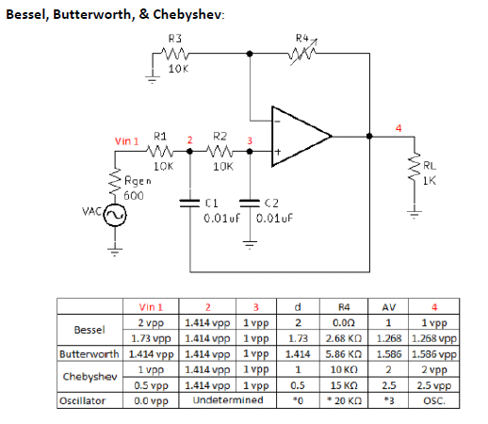Construct and measure an active ‐40db low pass filter circuit that is adjustable to produce a   Bessel, Butterworth, and Chebyshev response. with the sweep generator. **Instructor Check.**
8. Complete Conclusion and submit completed Check-Off sheet and Lab writeup in Moodle.